Dear Clerks and Councillors,
We were delighted to see so many familiar, as well as new, faces at Monday’s East Sussex AGM and subsequent joint Conference with West Sussex. We hope everyone who attended found it useful and had an enjoyable time. For East Sussex, we had representatives join us from almost 50% of our member councils which was wonderful to see.
For those who were unable to join us, please see below for a summary of the day. I also attach copies of the presentations by Mark Valleley on Transport for the South East and Steve Tilbury on planning. Also attached is a draft copy of the minutes from the ESALC AGM.
REPORT ON JOINT CONFERENCE HELD AT THE AMEX, 4.11.24
The joint ESALC/WSALC conference took some organising but overall has been deemed a great success, showcasing how SALC membership brings together councillors and clerks to receive vital information and share their own experiences.
After the respective AGM meetings, Chief Constable Jo Shiner gave an excellent presentation alongside temporary ACC Rosie Ross, stressing the breadth of responsibilities and challenges faced on a daily basis by Sussex Police. She ended with an exhortation for us all to thank those police we see for their efforts in keeping Sussex safe. A precis of the talk is attached for those who would like a reminder or to circulate it to their councillors.

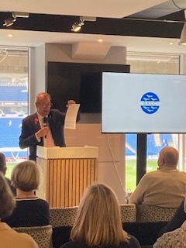
Our own Keith Stevens (Chair of ESALC) spoke about various issues concerning NALC. A comprehensive new NALC website has been launched, for which he encouraged all present to register. Keith explained how NALC is planning increased lobbying of the government and how important it is to let your local MP know good news stories; he also spoke about a move towards legislation permitting remote council meetings and the sanctioning of abusive councillors.

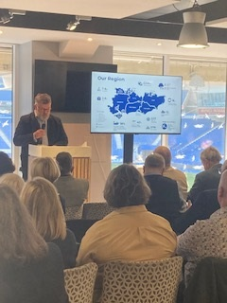
After lunch, the talks continued with Mark Valleley , Head of Strategy for Transport for the South East (based at County Hall in Lewes). Mark spoke about how the organisation is pushing for adequate infrastructure to support sustainable economic growth in our area. He said an online consultation is to begin on 10th December for 12 weeks, helping to inform their revised strategy with visions and goals up to the year 2050.*

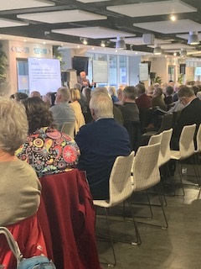
The final speaker was already known to many - Steve Tilbury, planning consultant, who talked about revised housing targets (fortunately Sussex is not as badly affected as some other areas in the south east) and the new Planning and Infrastructure Bill expected in the New Year. His talk was of interest to everyone in the room as these changes will affect all parishes in Sussex.
It was gratifying that all speakers were listened to with great attention and that many questions were asked at the end of each presentation. Douglas Denham St Pinnock, Chair of WSALC, finished by thanking everyone involved, saying the high attendance by councillors, clerks and exhibitors for this joint conference demonstrated the event’s success and that it should definitely be repeated.

* Udimore clerk (and Burwash councillor) Bob Franklin pointed out that he is a local conduit to Transport for the South East and can be contacted for information or to put forward ideas to the organisation. His email is parishclerk@udimore.org
POLICING PRESENTATION BY SUSSEX POLICE CHIEF CONSTABLE JO SHINER AND TEMPORARY ASSISTANT CHIEF CONSTABLE ROSIE ROSS

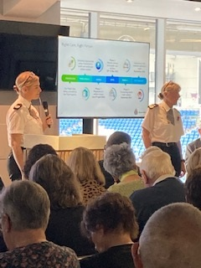
CC Jo Shiner began by summarising the huge range of responsibilities faced by police across Sussex including dealing with protests, roads, Gatwick airport, Premier League football, community policing, Beachy Head and the coastline. She emphasised that much of Sussex is rural – which brings its own challenges to policing – and how it can take 4 hours to get to one side of the county to the other.
Sussex Police is ahead of most other forces in its use of technology and data, with its PowerBi system which is updated every 15 minutes. This uses advanced analytics to identify issues arising around the county including community tensions where a policing response may be needed imminently.

In her 32 years of policing Jo said she had never known frontline police face as much danger as they do now. Having said this, the aim is always to police all communities fairly and with impartiality, working with numerous organisations and tiers of local government (including WSLAC and ESALC!) across Sussex.
She explained how resources are shared with Surrey Police in an unusual arrangement which saves money on joint resources but also means the command environment is a complex one. Unfortunately Sussex is one of the poorest forces in the country – receiving a low amount of funding because of the current Government funding formula.
The current establishment of 3,200 officers is due to rise again shortly (before natural attrition) and she emphasised that recruitment to Sussex Police is consistently successful. Interestingly, 62% of the last ‘detective only’ intake were women!
Jo ended her part of the presentation by saying that a large extent of the county’s crime remains hidden, including organised crime gangs who cause so much harm and misery to communities with activities such as County Lines. The police focus relentlessly on disrupting these OCGs but this work is unseen by the public.
T/ACC Rosie Ross then took over the presentation and spoke about how policing has become so much more complex than when she joined the force 24 years ago. Her ‘A Day in the Life of Sussex Police’ slides showed some interesting statistics including the rather daunting figure of 2,056 contacts made every day via email, phone or social media. All incidents need to be assessed and prioritised.
The police rely hugely on the support of local councils and are aware that, through this contact, they can gauge how communities feel about the policing service they receive. Engagement is really significant, enabling the police to maintain the support of the community and ensure that people understand the importance of reporting.
Rosie also spoke about the Right Care Right Person initiative which resulted last year in hours saved equating to that of 41 full time police officers. The issues presented by people with mental health challenges, as well as alcohol and drugs, complicate an already difficult situation but Right Care Right Person tries to make sure that the police are not bearing the whole brunt of the work involved.
Her talk ended by stressing that the fear of crime is often worse than the reality and that working together in a collaborative way is the best path to tackling issues successfully.
Questions included
The role and safety of PCSOs - it was stressed that, unlike some forces, Sussex is currently determined to keep its PCSOs and hugely values their contribution. Every effort is made to keep them safe and there’s an ongoing review about safety equipment.
Parking issues in a residential street – residents should get together en masse and speak to the local council as well as the police. There’s power in numbers.
SSRP – why has Sussex pulled out – Jo has the national portfolio for roads and firmly believes that there’s a better model for dealing with roads issues, especially better use of technology. This was also the answer to a question about speeding in Hamsey.
Shoplifting – Sussex Police has a dedicated Business Crime Unit which solves over 50% of cases where there is strong evidence provided. However it’s important that shops support the police by reporting crime and supplying good quality evidence.
County Lines – the police are always keen to receive any information and Jo Shiner stressed that councils should use Trevor Leggo as a conduit to liaise with the police if necessary.
101 – the current wait time is 2 minutes 3 seconds but if there are any concerns about long wait times for a specific phone call, please feed that back to the police.
Trevor Leggo thanked Jo and Rosie, expressing his appreciation of the exceptionally strong relationship between ESALC/WSALC and Sussex Police.

