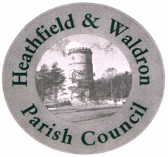

EVENTS, ENVIRONMENT AND BURIALS OFFICER – FEB 2025

Post No PC08

Notes for Applicants

Thank you for expressing an interest in this role.
The application pack consists of an application form, job description, person specification, job advert and these notes and are available for download on the Council’s website – www.hwpc.org.uk, by email to Helen Johnson at clerk@hwpc.org.uk or by telephone on 01435 865700. Completed forms can be emailed or posted to:

Miss Helen Johnson
Clerk to Heathfield and Waldron Parish Council
73 High Street
HEATHFIELD
TN21 8HU

If you have any queries or would like any further information, please contact the Clerk, Helen Johnson on 01435 865700 or clerk@hwpc.org.uk.
Successful applicants will be invited for interview to be held on 5th March 2025.
Interviews will take place at the Parish Council office, if you have accessibility concerns please contact the Clerk prior to the interview so that we can arrange suitable access.

