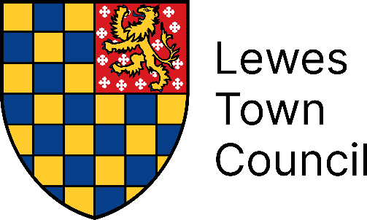

Appointment of a Community Engagement Coordinator

(Full-Time 37 hours per week)

Salary Scale SCP: 13 - 17 (starting at £28,163 per annum FTE)

Plus Generous Local Government Average Salary Pension Scheme

Are you passionate about working with the community? Do you enjoy event planning and delivering public events? Are you a natural networker with an ability for fostering strong relationships?

Lewes Town Council is seeking a motivated and skilled community worker to join its team. This exciting new role places the community at the heart of everything we do. You will have a broad remit, from developing a volunteer programme and managing the council’s grants programme to supporting delivery of partnership projects and driving engagement with schools and youth groups.

Engaging with residents, businesses, and community groups, this role is integral in connecting the council with the people it serves. If you want a role with meaningful impact and have ideas to drive participation and collaboration, email recruitment@chrgs.co.uk to receive a recruitment pack and application form.

Application forms must be returned by 11pm on Sunday, 22 June 2025.
Interviews will take place in July 2025.

