Independent Examiner’s Report to the Members of Wealden Association of Local Councils

I report on the accounts of the Association for the year ended 31st March.2025

Respective responsibilities of the Association and the Examiner

The Officers of the Association are responsible for the preparation of the accounts. The Officers consider that an audit is not required for this year and that an independent examination is needed.

It is my responsibility to:

- examine the accounts.
- follow the procedures sufficient to ascertain that appropriate accounting records have been maintained and accounts are prepared in accordance with those records
- state whether particular matters have come to my attention.

Basis of the Independent Examiner’s report

My examination was carried out in accordance with the responsibilities set out above. An examination includes a review of the accounting records kept by the Association and a comparison of the accounts presented with those records. It also includes consideration of any unusual items or disclosures in the accounts, and seeking explanations from the Officers concerning any such matters. The procedures undertaken do not provide all the evidence that would be required by an audit and consequently I do not express an audit opinion on the view given by the accounts.

Independent Examiner’s statement

In connection with my examination no matter has come to my attention which gives me reasonable cause to believe that in any material respect the requirements

- to keep proper accounting records
- to prepare accounts which accord with the accounting records

have not been observed.

No other matter has come to my attention in connection with my examination to which, in my opinion, attention should be drawn in order to enable a proper understanding of the accounts to be reached.

The Balance of £3265.78 as at 31/03/2025 , is correct.

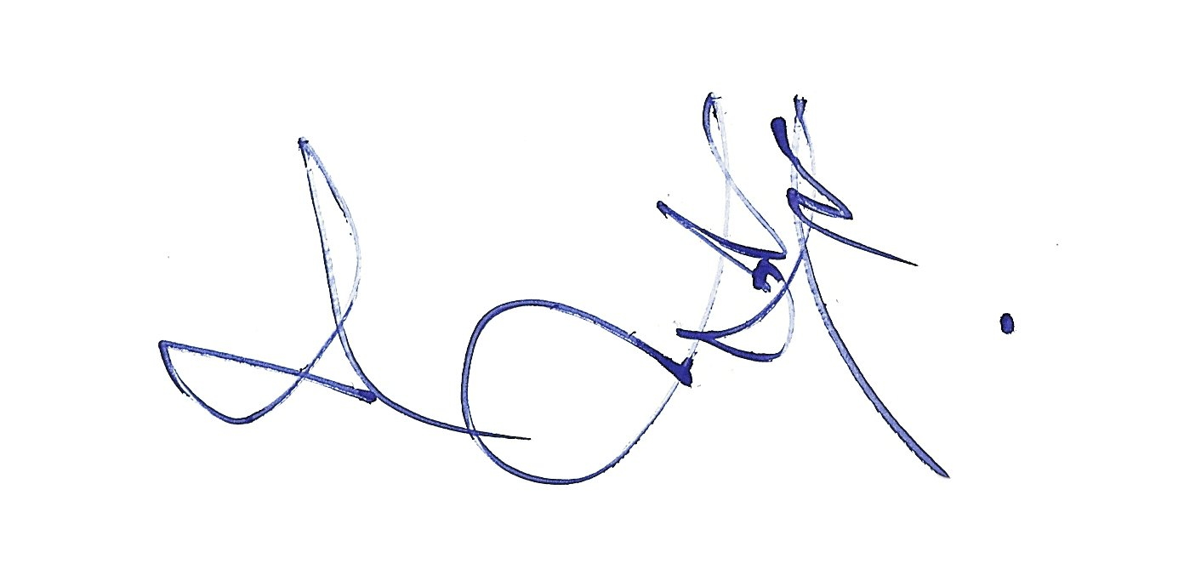

Peter Frost
Peter.J.Consultants: Lyoth Cottage, Lyoth Lane, Lindfield, W Sx. RH16 2QA

Date: 22/04/25

