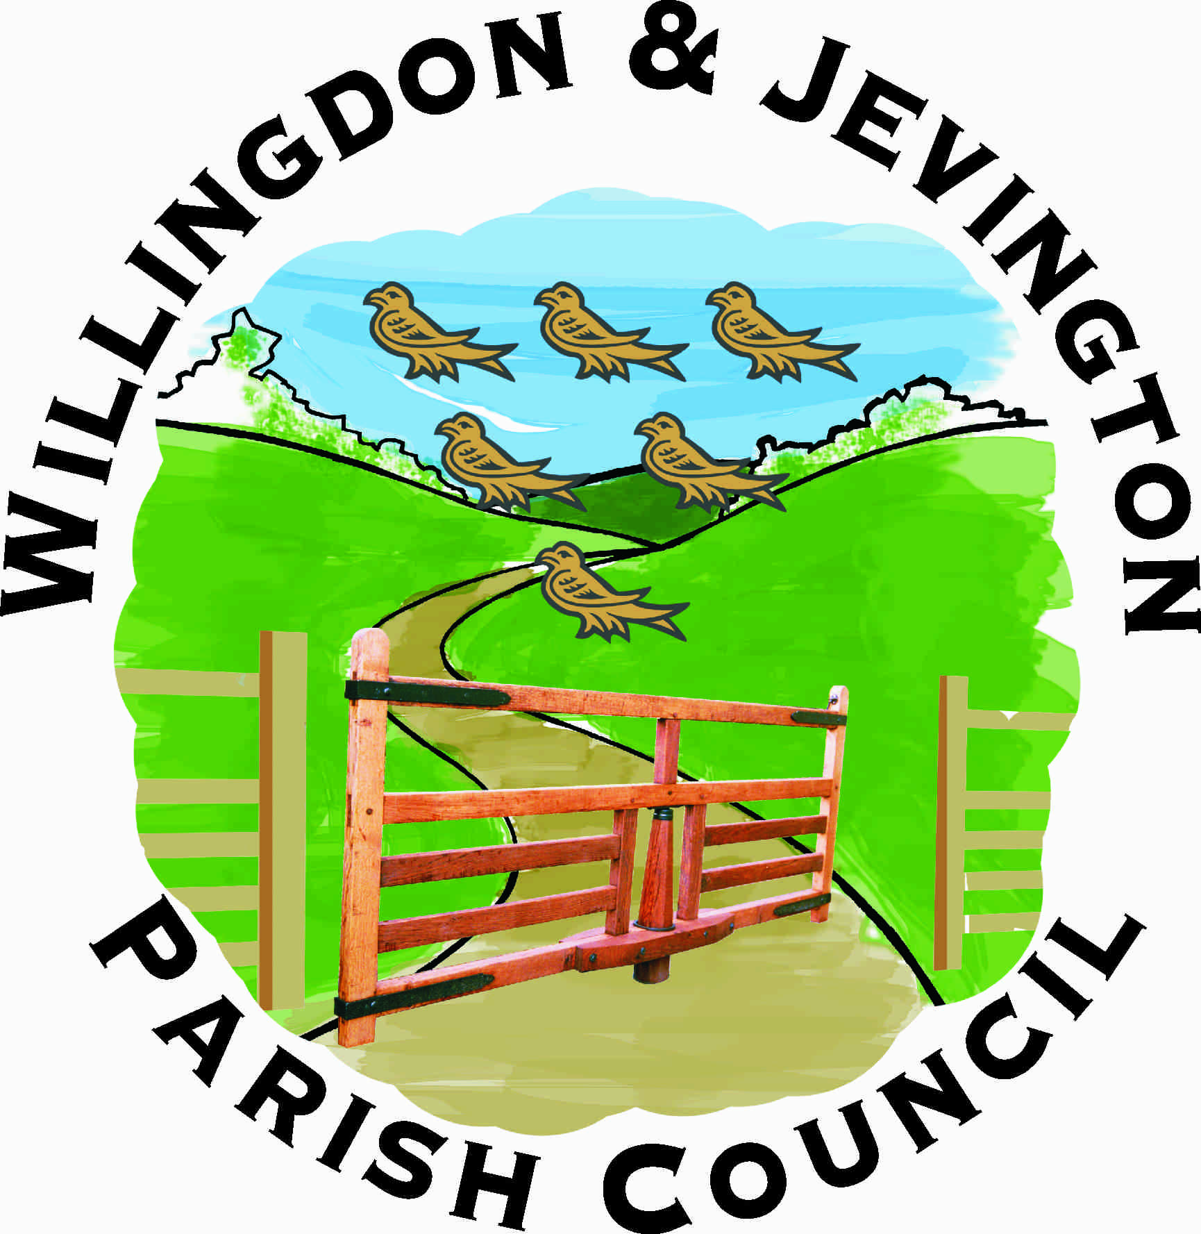

JOB DESCRIPTION

JOB TITLE: PARISH CLERK

GRADE: TBC

REPORTS TO: CHAIR, PARISH COUNCIL

HOURS: 30 HOURS PER WEEK

DATE: 1ST OCTOBER 2025

LINE MANAGER FOR: CEMETERY MANAGER & ASSISTANT CLERK
ADMINISTRATIVE OFFICER

POST HOLDER: VACANCY

OVERALL RESPONSIBILITIES

The Clerk to the Council will be the Proper Officer of the Council and as such is under a statutory duty to carry out all the functions, and in particular to serve or issue all the notifications required by law of a local authority's Proper Officer. The Clerk will be totally responsible for ensuring that the instructions of the Council in connection with its function as a Local Authority are carried out. The Clerk is expected to advise the Council on, and assist in the formation of, overall policies to be followed in respect of the Authority's activities and in particular to produce all the information required for making effective decisions and to implement constructively all decisions. The person appointed will be accountable to the Council for the effective management of all its resources and will report to them as and when required. The Clerk will be the Responsible Financial Officer and responsible for all financial records of the Council and the careful administration of its finances.

Specific Responsibilities

- To ensure that statutory and other provisions governing or affecting the running of the Council are observed.

- To monitor and balance the Council's accounts and prepare records for audit purposes and VAT.

- To ensure that the Council's obligations for Risk Assessment are properly met.

- To prepare, in consultation with appropriate members, agendas for meetings of the Council and Committees. To attend such meetings and prepare minutes for approval.

- To attend all meetings of the Council and all meetings of its committees, sub-committees and working groups.

- To receive correspondence and documents on behalf of the Council and to deal with the correspondence or documents or bring such items to the attention of the Council. To issue correspondence as a result of instructions of, or the known policy of the Council.

- To receive and report on invoices for goods and services to be paid for by the Council in accordance with the Financial Regulations and to ensure such accounts are met. To issue invoices on behalf of the Council for goods and services and to ensure payment is received.

- To study reports and other data on activities of the Council and on matters bearing on those activities. Where appropriate, to discuss such matters with administrators and specialists in particular fields and to produce reports for circulation and discussion by the Council.

- To draw up both on his/her own initiative and as a result of suggestions by Councillors proposals for consideration by the Council and to advise on practicability and likely effects of specific courses of action.

- To supervise any other members of staff as their line manager in keeping with the policies of the Council and to undertake all necessary activities in connection with the management of salaries, conditions of employment and work of other staff.

- To monitor the implemented policies of the Council to ensure they are achieving the desired result and where appropriate suggest modifications.

- To act as the representative of the Council as required.

- To issue notices and prepare agendas and minutes for the Parish Meeting: to attend the assemblies of the Parish Meeting and to implement the decisions made at the assemblies that are agreed by the Council.

- To prepare, in consultation with the Chairman, press releases and updates for noticeboards, websites and other social media about the activities of, or decisions of, the Council.

- To attend training courses or seminars on the work and role of the Clerk as required by the Council.

- To work towards the achievement of the status of Qualified Clerk as a minimum requirement for effectiveness in the position of Clerk to the Council.

- To continue to acquire the necessary professional knowledge required for the efficient management of the affairs of the Council: Suggested is membership of your professional body The Society of Local Council Clerks.

- To attend the Conference of the National Association of Local Councils, Society of Local Council Clerk’s, and other relevant bodies, as a representative of the Council as required.

END

