Minutes of the Annual General Meeting of Lewes District Association of Local & Parish Councils (LDALC)
held in the Downland Room at the offices of
Action in Rural Sussex, 48 High Street, Lewes
on 18th September 2025
Councillors attending : Liz Boorman and Richard Honeyman (Seaford Town Council), Harriet Martin (Wivelsfield Parish Council), , Ian Douglas and Ken Whitehouse (Kingston Parish Council), Elizabeth Berry (Chailey Parish Council), Cathy Gallagher (Telscombe and Peacehaven Town Councils), Imogen Makepeace (Lewes Town Council), Christopher Baker (Chairman, Iford Parish Meeting and Chairman of LDALC), Ken Dry (Clerk, Newhaven Town Council), Tom Warder (Action in Rural Sussex).
Also present: James McCleary M.P. for Lewes, Cllr. Stella Spiteri (Lewes District Council- Kingston Ward), Trevor Leggo (Chief Executive Officer, East Sussex Association of Local Councils) and Paul Richards (Secretary).
INTRODUCTION
The Chairman welcomed the 10 LDALC representatives and guests named above to the meeting. And asked for leave of the meeting for James MacCleary, MP to speak before the items on the agenda which was projected to the screen, because he had a commitment to collect one of his children from school. James McCleary provided an update included:
- Local Government Devolution:
  - He explained the various options and proposals for future Unitary Council structures. He favoured East Sussex County Council’s (ESCC) proposal but advised that both ESCC and West Sussex County Council (WSCC) proposals would need to be approved by the Secretary of State;
  - He discussed the Brighton and Hove proposals to widen its Unitary boundaries, but he opposed these plans;
  - He suggested that the role of town and parish councils is not clear in the Government’s proposals and is concerned about the transfer of power, without sufficient funding.
- Mayoral elections – he sees this as a huge opportunity and an exciting prospect, especially in their future role as the Strategic Transport Authority. He suggested that this is a key position for developing better connections across Sussex.
- Constituency – he had visited each parish and village across his constituency noting local concerns, especially rural speeding, in the 25 meetings he had attended.
- Planning – he suggested that the Planning Infrastructure Bill would be very important and would give more powers to local authorities e.g. compulsory purchase.

- APOLOGIES FOR ABSENCE
No apologies for absence had been received.
The Chairman asked for leave of the meeting to depart from the agenda projected to the screen of the meeting, so that members would receive the Finance Report before deciding who to elect to LDALC’s offices, Chairman, Secretary, Hon. Treasurer and Hon. Auditor. The Chairman said that the Annual General Meeting scheduled to take place in May 2025 had been postponed because the accounts had not been prepared. It had been necessary to constitute them from the paper records that were available.

- FINANCE REPORT
  - Financial Statement for the period 1 April 2024 – 31 March 2025 (for Approval).
The Financial Statement was presented by the Chairman and showed a deficit of £585.86 for the period. The Chairman explained that the Secretary had been overpaid by £67:50 in the mistaken belief that a minute exists recording an increase in the secretary’s honorarium from £560:00 per annum to £650:00 per annum. The Chairman apologised for not having insisted on prior sight of the minute recording the increase. The notes to the accounts were reviewed and Members agreed to APPROVE the Financial Statement. The Financial Statement is attached at Appendix A.
  - Draft Budget for the year 1 April 2025 – 31 March 2026 (for Approval and Ratification).
The draft budget was presented by the Chairman. He proposed no increase to Member subscriptions and thanked the Town Clerk of Seaford for offering to host future meetings. He also asked Members to suggest candidates for the role of Secretary to LDALC, as the current Secretary is unwell and unable to carry out the role. Trevor Leggo said that he has been authorised by the absent Secretary to share with the meeting that she is very sick. Those present wished her well. The Chairman proposed the Secretary’s honorarium be set pro-rata at £650 for the year. Members agreed to APPROVE the draft budget, which is attached at Appendix B. A Member asked if LDALC could fund future training? The CEO of ESALC reminded Members that training from their County Association is free of charge. The Chairman agreed to discuss this, after the meeting, with the Member.
  - Changes to:
  - 3.3.1 - the mandate’s signatories with Barclays Bank plc on the two LDALC accounts (Community Account and Business Premier Account).
The Members APPROVED the changes to the mandate (on each account), the signatories are now the Chairman, Christopher Baker and Trevor Leggo and the absent Secretary. Three people, including the late Chairman, who no longer have any connection with LDALC, had been removed from the mandate.
  - 3.3.2 - the two LDALC accounts becoming on-line accounts: two card readers and two cards, one of each held by Trevor Leggo and Christopher Baker: one holder to set up payments, the other to release payment, so as to achieve separation of duties (for Ratification).
The Members RATIFIED the changes in paragraph 3.2.2

- AUDITOR’S LETTER TO LDALC MEMBERS.
The Chairman explained that the auditor’s letter which had been circulated with the Notice of Meeting and its Agenda does not make good reading: the issues raised are being addressed. The appointment of a Secretary is seen as crucial to resolve previous issues. The Chairman thanked the auditor, Keith Robertson, for his time in reviewing the accounts and identifying the key issues. He also thanked Emily Simpson (ESALC) for progressing the subscription invoices for LDALC for the current year, 2025/2026 and for following up for subscription arrears for 2024/2025, which cover 2023/204 too and for which no invoice had been submitted. The auditor’s letter to Members is attached at Appendix C.
Members questioned the lack of governance: The preparation of accounts had been requested in 2024. No annual accounts necessitated the May AGM’s postponement, which is very unsatisfactory and that he should have been very insistent earlier. He re-emphasised the need for a Secretary who is able to address the Issues identified by Keith Robertson.

- ELECTION OF THE CHAIRMAN
Members proposed that the current Chairman, Cllr Christopher Baker, be re-appointed as Chairman. This was agreed unanimously. The Chairman reported that he had asked Keith Robertson if he would audit 2025/26? It depends. To audit, he must remain independent of the preparation of accounts. The appointment of the other LDALC officers was deferred to the next meeting.

- AIRS PRESENTATION
The Chairman thanked AIRS for hosting the meeting and invited Tom Warder, Director of Rural Community Services, to make a short presentation. His presentation slides are attached at Appendix D.

- DEVOLUTION AND LOCAL GOVERNMENT RE-ORGANISATION
The Chairman had been asked to present information regarding the transfer of property as highlighted by Section 53 of the English Devolution and Local Government Re-Organisation Bill (the Bill) before Parliament. His presentation slides are attached at Appendix E.

The Chairman offered to host a workshop(s) to help Members understand the provisions of the Bill.

There being no further business, the meeting closed at 4:58pm

APPENDIX A – FINANCIAL STATEMENT TO 31st March 2025
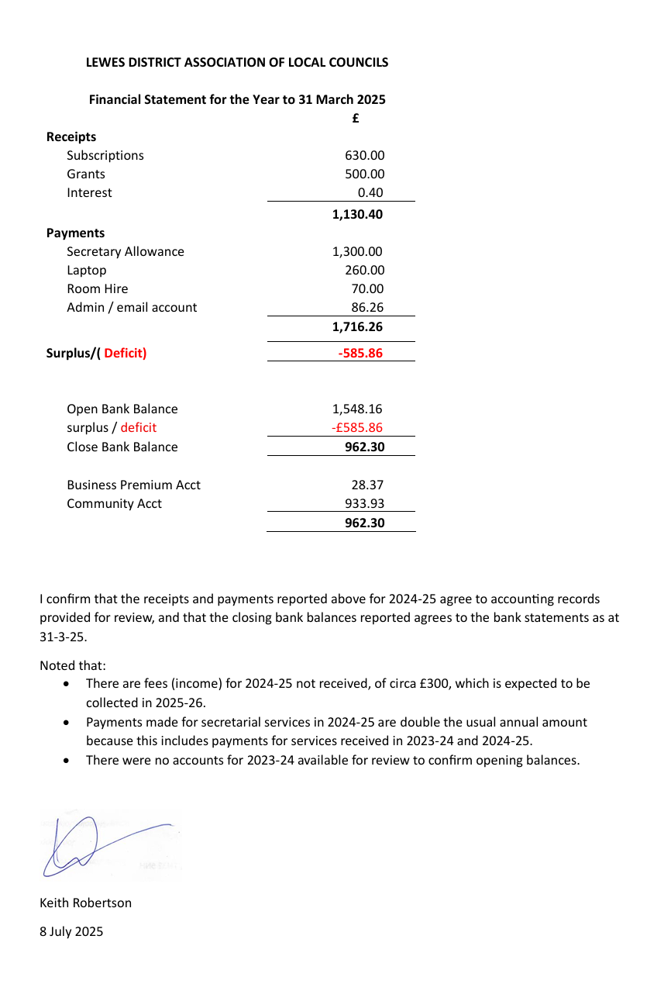
APPENDIX B – DRAFT BUDGET 2025/26
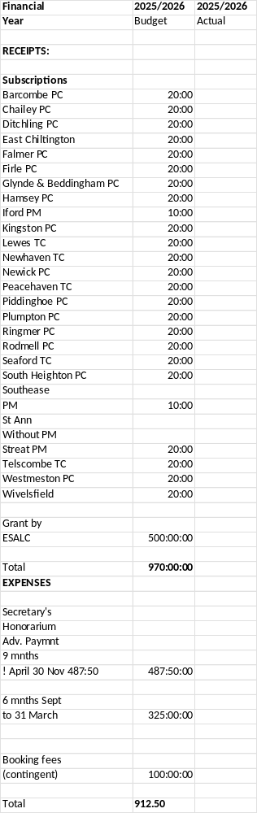

APPENDIX C - Report to LDALC members to accompany the accounts for 2024-25
To: The Members of the Lewes District Association of Local Councils
Copy via: Trevor Leggo and Christoper Baker
Date: 8th July 2025
Report to LDALC members to accompany the accounts for 2024-25
When reviewing the accounting records for LDALC for the year to 31 March 2025 I found that much of the information that would usually be available for review was not present. I do not know if that information is elsewhere but it was not available. I was able to sign that the accounts produced were consistent with the transactions in the bank account and that the closing balances in the accounts agreed to the bank accounts, albeit with much of the detailed supporting information missing or not available.
This does raise some questions on governance which members should consider and consider if any changes are needed. The following is not an audit of processes or a recommendation to members of any changes needed but it may help to highlight issues for review.
- There were no prior year accounts for 2023-24 or a 2023-24 cash book to review. This would usually be available to at least confirm the opening balances in the Association’s accounts.
- There was no cash book maintained during the year for 2024-25, or at least no cash book available for review. Christopher Baker was able to construct a cash book from bank statements and this was used to produce the accounts reviewed for 2024-25. Maintaining a cash book is a basic requirement for any set of accounts and should be produced as soon as possible for 2025-26.
- The cash book should be reconciled to the bank statements, and a record of fees due be maintained. This ensures that all receipts and payments have cleared the bank and that any amounts owned can be tracked.
- It was apparent that some fees due for 2024-25 were not collected but I was unable to see from the records available a debtor list. Some of the receipts recorded on the bank statements did not record the giver and the paying in books also did not record the giver. This again prevented an analysis of debtors.
- There should be payment information on file (invoices, emails, references to minutes) to support payments recorded in the cash book. I could not find these in the records available for review. Similarly, cheque book stubs should be initialled by persons signing cheques. In discussion with Trevor and Christopher I was able to confirm the reasons for all payments but a better process of recording the detail and the authorisation of payments should be considered.
- It is good practice for members to see an update of the accounts during the year rather than wait for the year end.

Best regards
Keith Robertson

APPENDIX D – AIRS presentation

Separate attachment

APPENDIX E - DEVOLUTION AND LOCAL GOVERNMENT RE-ORGANISATION
